**DAILY ONLINE ACTIVITIES SUMMARY**

|  |  |  |  |  |  |  |  |  |
| --- | --- | --- | --- | --- | --- | --- | --- | --- |
| **Date:** |  | **11-06-2020** | |  | **Name:** |  | **Suhas Prasad Shetty** | |
|  |  |  |  |  |  |  |  |  |
| **Sem &** |  | **8th sem B sec** | |  | **USN:** |  | **4AL16CS080** | |
| **Sec** |  |  |  |  |  |  |  |  |
|  |  |  |  |  |  |  |  |  |
|  |  |  |  | **Online Test Summary** | | |  |  |
|  | |  |  |  |  |  |  |  |
| **Subject** | | **SMS** | |  |  |  |  |  |
|  | |  |  |  |  | |  |  |
| **Max.** | | **60** | |  | **Score** |  | **60** | |
| **Marks** | |  |  |  |  |  |  |  |
|  |  |  |  | |  |  | |  |
|  |  |  | **Certification Course Summary** | | | | | |
|  | |  |  |  |  |  |  |  |
| **Course** |  | **Configure and Deploy AWS Client VPN** | |  |  |  |  |  |
|  |  |  |  |  |  | |  |  |
| **Certificate** | |  | **AWS** |  | **Duration** | |  | **30mins** |
| **Provider** | |  |  |  |  |  |  |  |
|  |  |  |  |  |  | |  |  |
|  |  |  |  | **Coding Challenges** |  | |  |  |
|  | | | | | | |  |  |
| **Problem Statement:** program to find the fibbonnacci series | | | | | | |  |  |
|  | | | |  |  |  |  |  |
| **Status: completed** | | | |  |  |  |  |  |
|  | | | |  |  | |  |  |
| **Uploaded the report in Github** | | | |  | **yes** | |  |  |
|  | | | |  |  | | | |
| **If yes Repository name** | | | |  | **Sathwikgutti** | | | |
|  | | | |  |  | |  |  |
| **Uploaded the report in slack** | | | |  | **yes** | |  |  |
|  |  |  |  |  |  |  |  |  |

**Online Test Details**

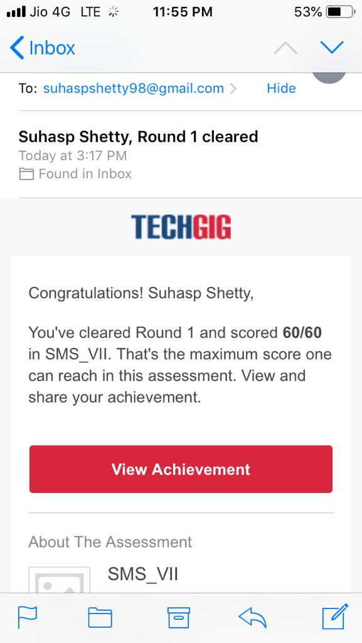

**Certification Course Details**

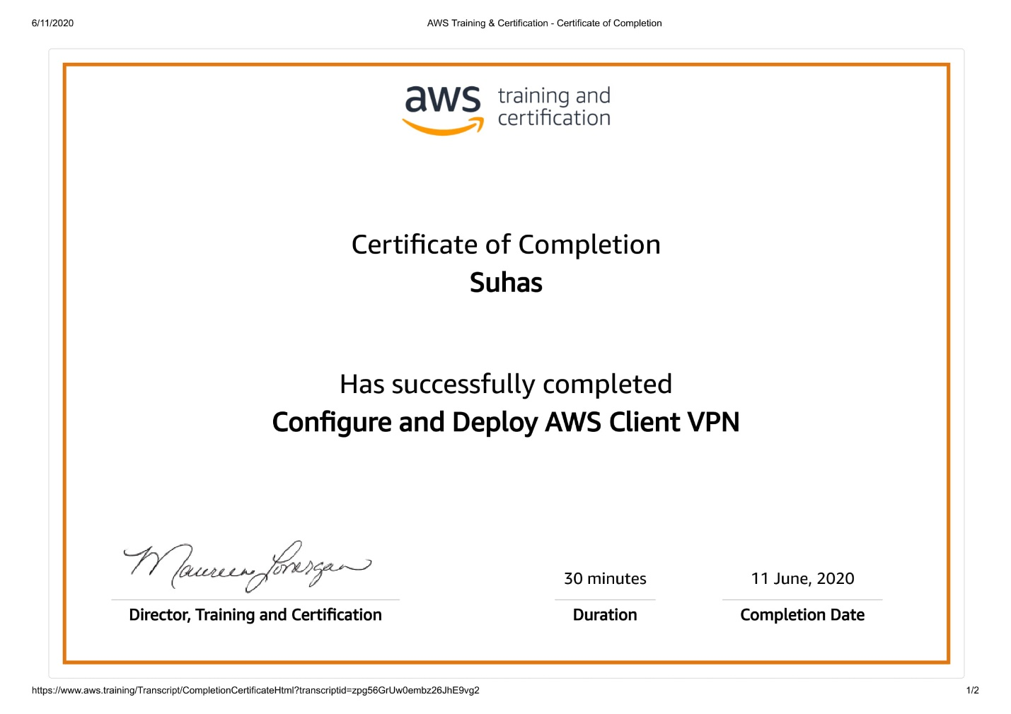

**Coding Challenges Details**

def recur_fibo(n):

if n <= 1:

return n

else:

return(recur_fibo(n-1) + recur_fibo(n-2))

nterms = 10

if nterms <= 0:

print("Plese enter a positive integer")

else:

print("Fibonacci sequence:")

for i in range(nterms):

print(recur_fibo(i))